**Create an Elastic IP address and associate it with an instance, so that if that instance is getting restarted then also the public IPv4 address remains the same:**

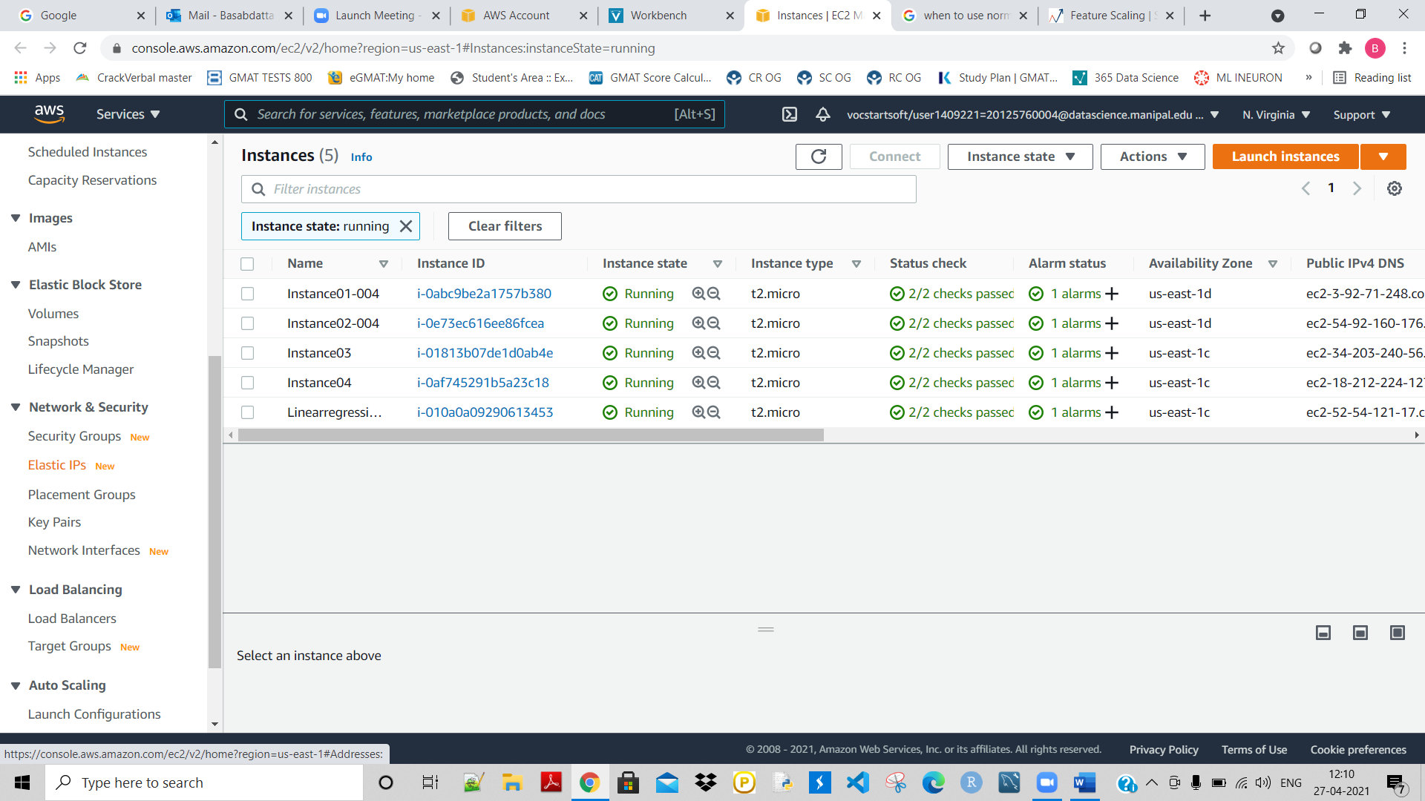

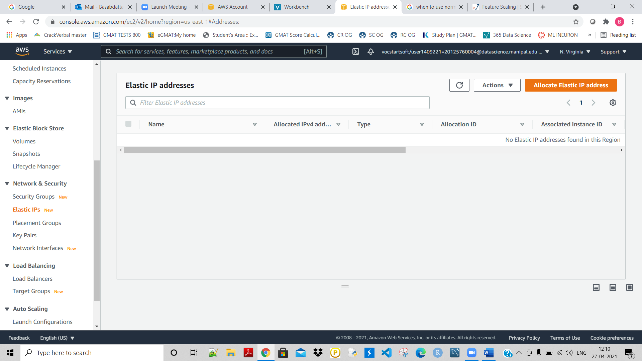

Allocate EL IP address:

Leave everything as default and allocate:

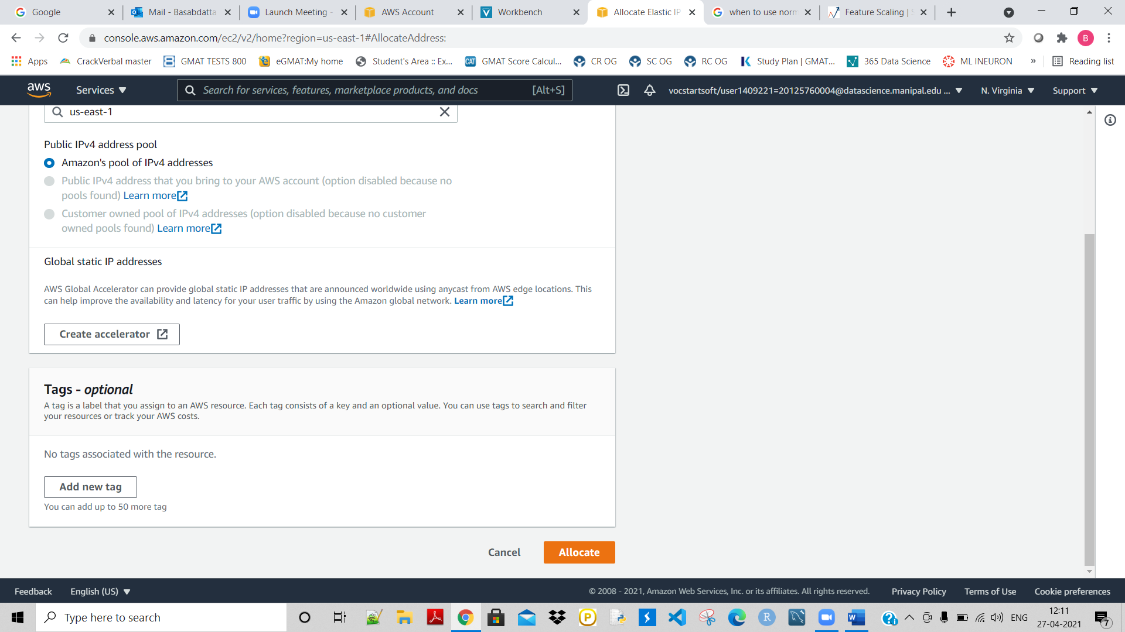

Then give it a name:

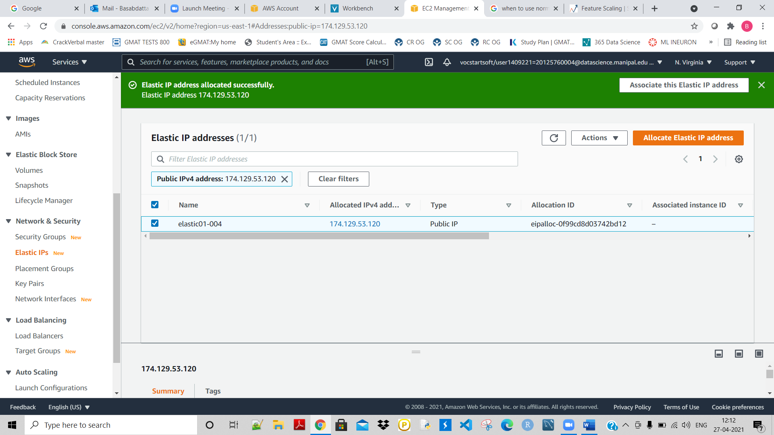

Go to action- go to associate elastipc IP address:

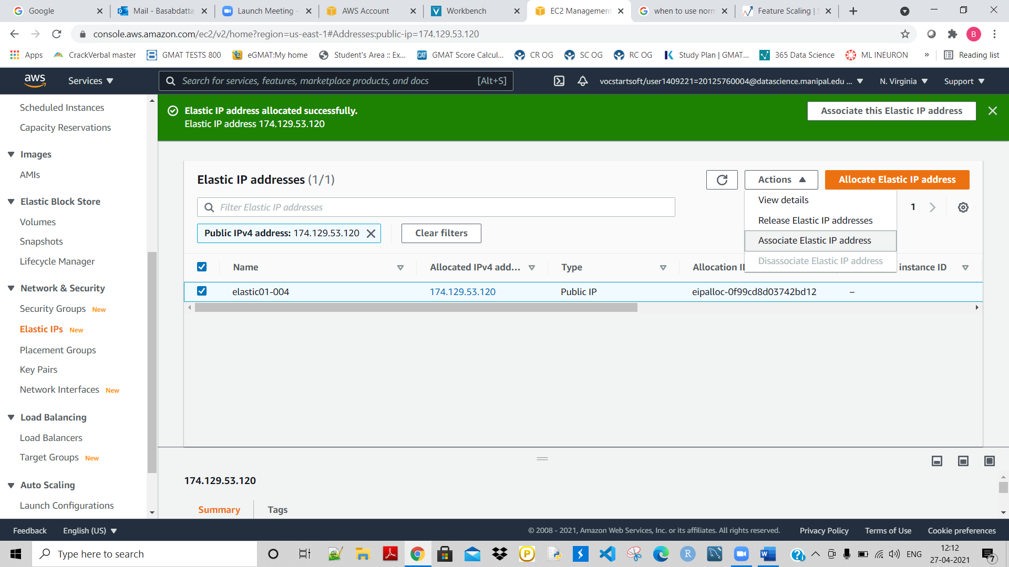

Next choose the instance here:

As shown:

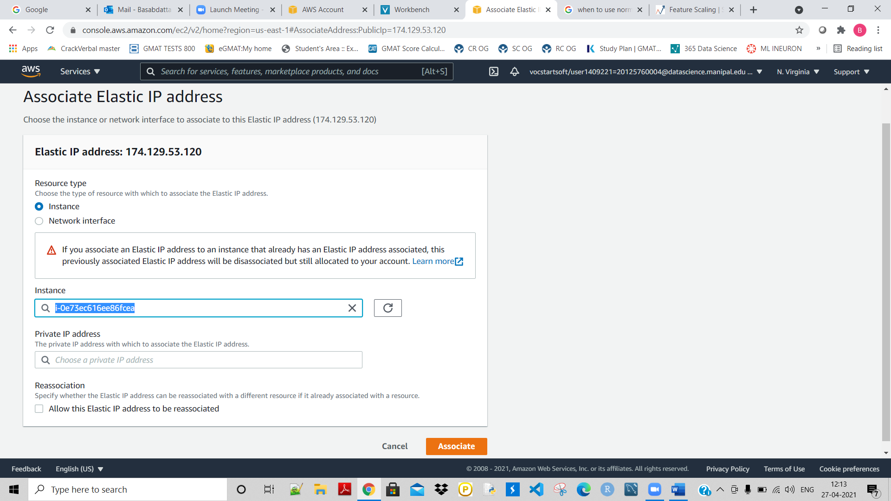

Next click on associate:

But check the insatnace PUBLIC IPv4 first:

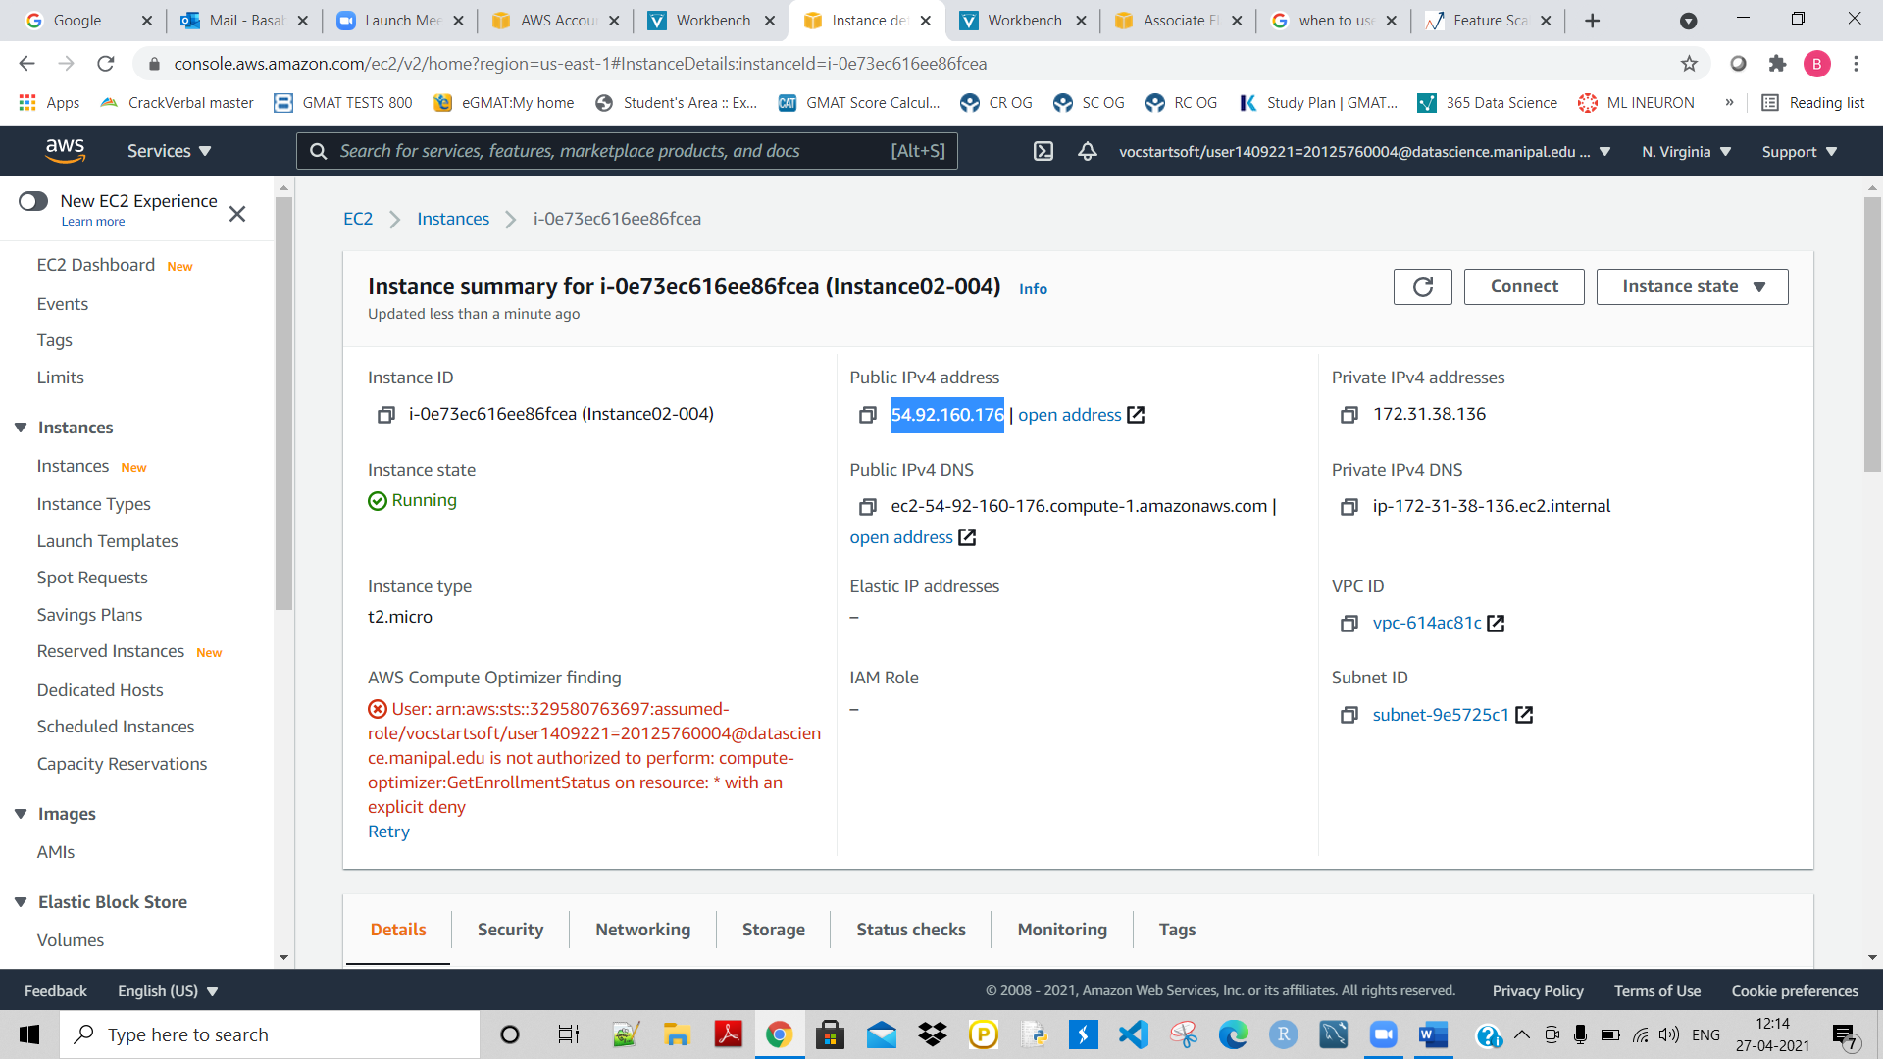

Now click on associate: